Scenario: User bypasses SSL warning
Step: Launch "koenigsegg_page" WebPage - PASS
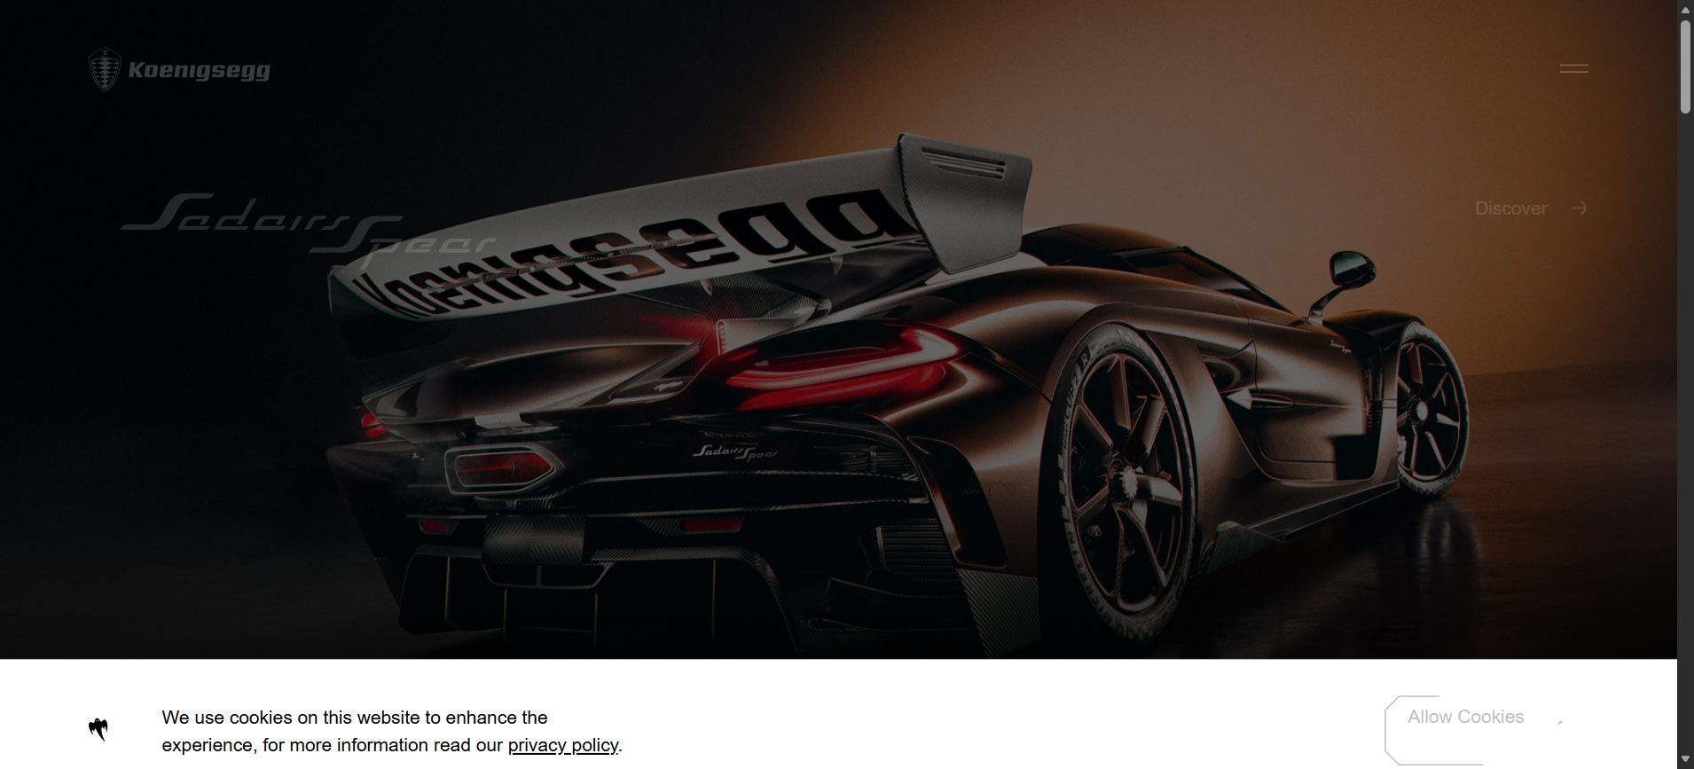
Step: When the user clicks the Advanced option and clicks Proceed - PASS
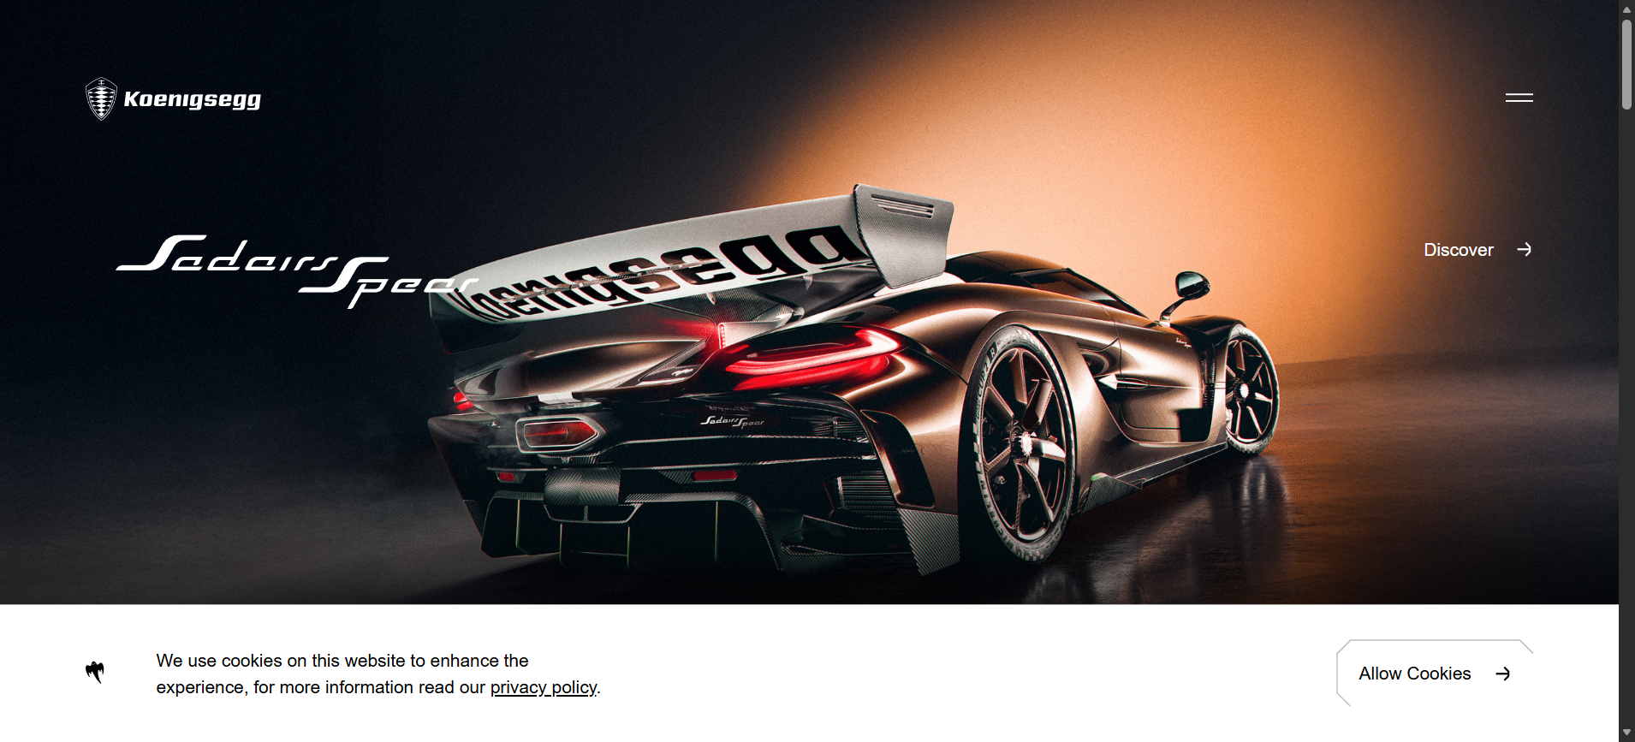
Step: And the user validate the page title with"Home - Koenigsegg" - PASS
Step: Then the user validate the page URL with"https://www.koenigsegg.com/home" - PASS
Execution Summary:
Total Steps: 4
Passed: 4
Failed: 0

